Assignment: 9

Name: Divya Shah Branch: IT/V Roll No.: 115 Date:20/10/2023

**Aim**: Installation of Nagios on Ubuntu system.

**LO mapped**: LO1, LO5

**Theory**:

Nagios: Open-source monitoring tool for real-time IT infrastructure health checks and alerts, helping ensure system reliability.

1. **Update System Packages**:

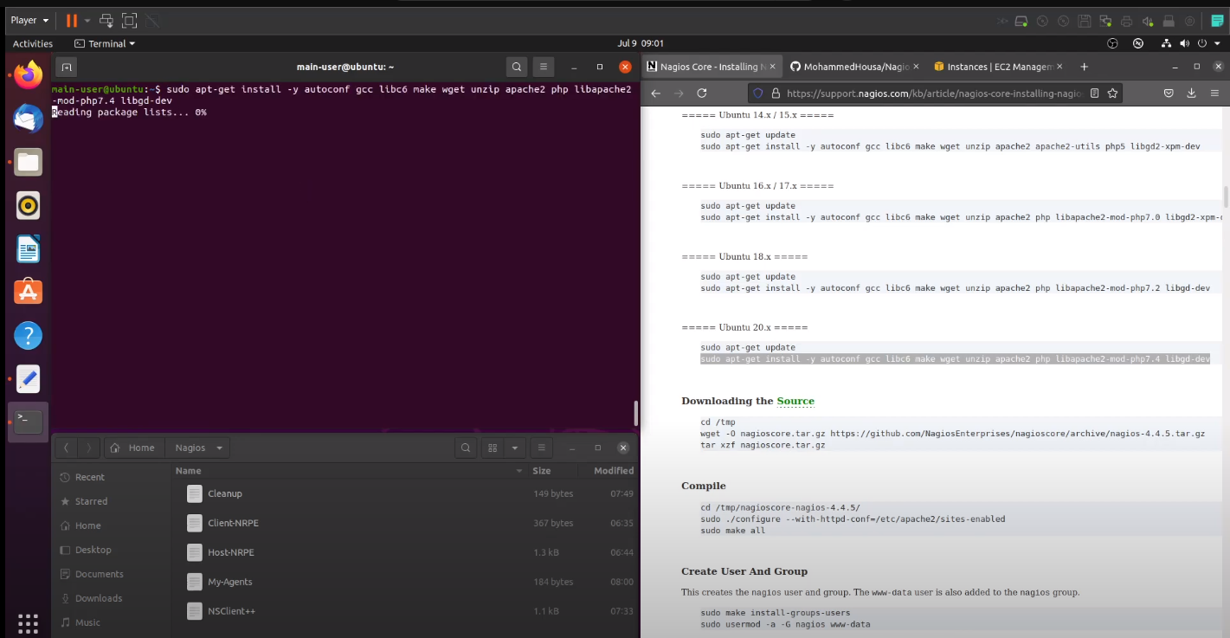

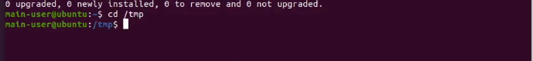

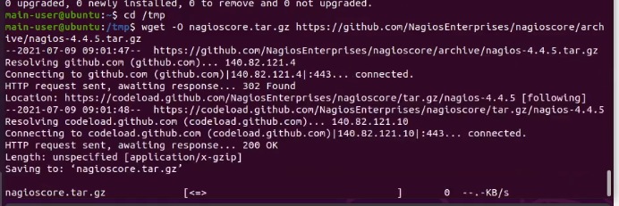





1. **Install Prerequisites**:

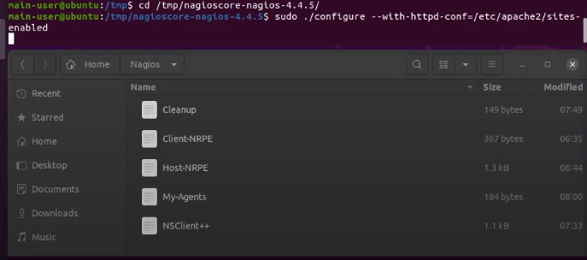



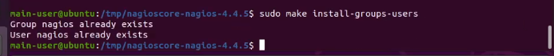

1. **Create Nagios User and Group**:





1. **Download Nagios Core**:

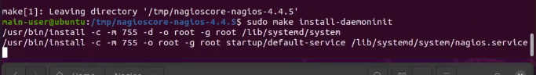

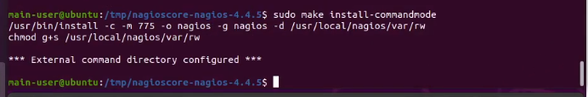

1. **Compile and Install Nagios Core**:



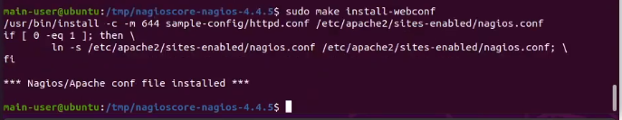

1. **Configure Nagios Web Interface**:





1. **Create a Nagios Admin User**:

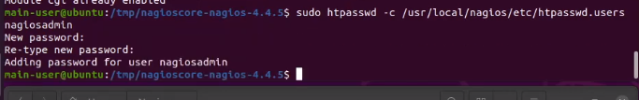



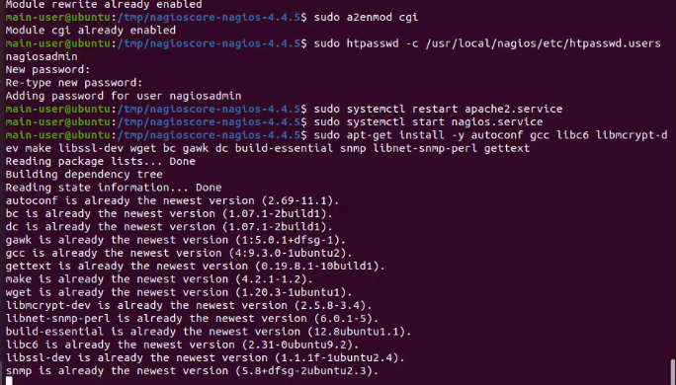

1. **Start Apache Web Server**:

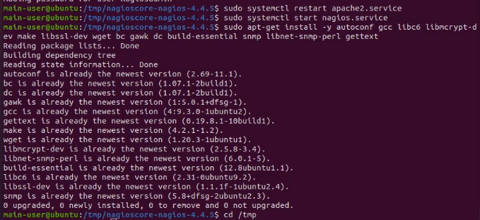

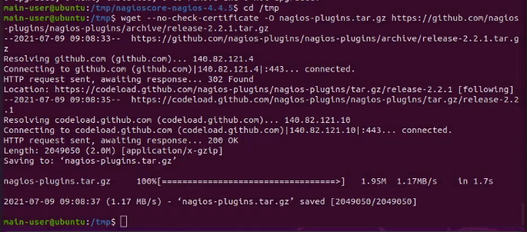

1. **Start Nagios Service**:

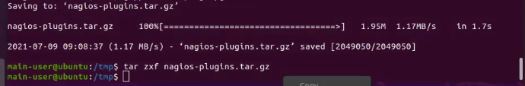

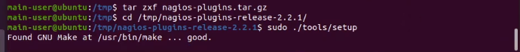

1. **Check Nagios Configuration**:





1. **Restart Apache and Nagios**:

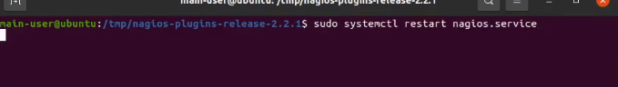

1. **Access the Nagios Web Interface:**

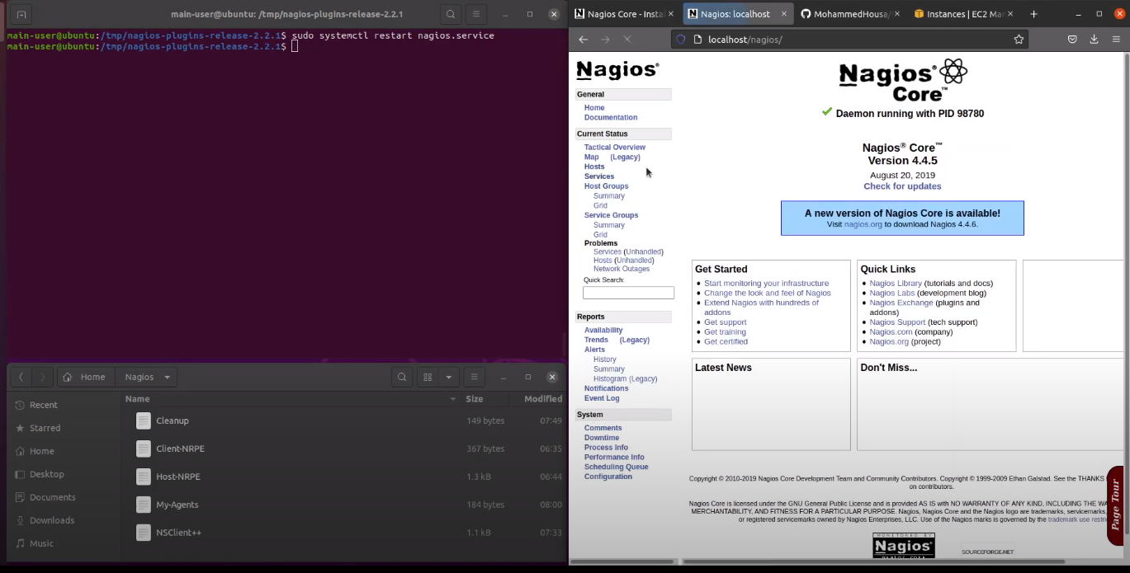

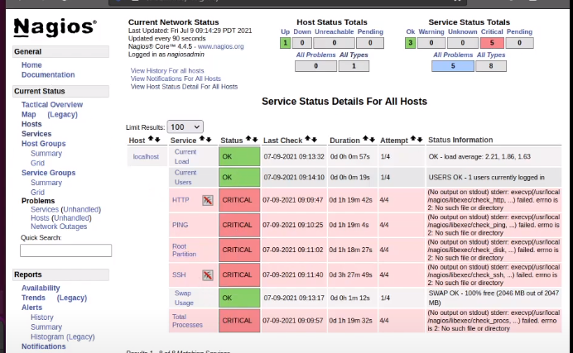

Open a web browser and go to http://localhost/nagios (or the IP address of your Ubuntu server) and log in with the nagiosadmin credentials you created.

You've successfully installed and configured Nagios on your Ubuntu system. You can now begin adding hosts, services, and configuring monitoring checks through the web interface.

**Conclusion**: We installed Nagios on Ubuntu System successfully.